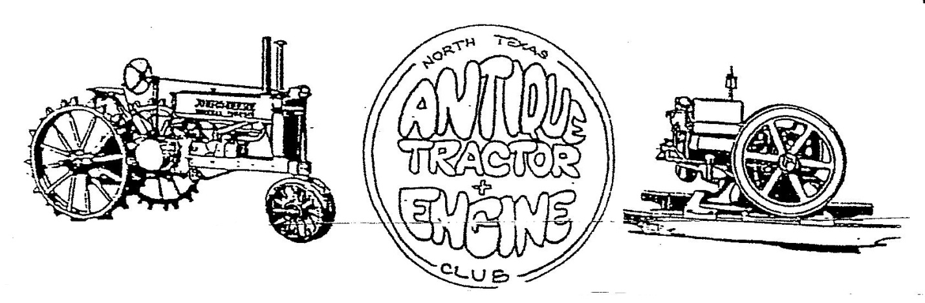
History: In the winter of 1990-1991, a small group of collectors of old engines and tractors became acquainted and the idea of forming a club in our was conceived. The first informal meeting was held in late January of 1991 with about 25 people attending. By March 10, 1991, a club was born. By the end of its first year, 100 members had banded together from all over North Texas.
Purpose: The specific and primary purpose of the North Texas Antique Tractor and Engine Club is to promote the restoration, preservation and exhibition of antique engines, tractors, farm machinery and related items.
Activities: The club puts on an annual show open to the public the second full weekend in June, participates in various parades and civic activities throughout the area. A monthly meeting is held the third Thursday of the month at 7:00 P.M. The meeting is usually held at the Terrell Chamber of Commerce; 1314 W. Moore Ave.; Terrell, TX.
Membership: We welcome anyone to join the Club. The annual dues are $25.00 for a family membership, which is defined as a father and/or mother and all children under age 18 living at home. With your membership, you will be able to participate in Club activities and receive a monthly newsletter. The location of the next meeting will be listed in the newsletter.
Club Webpage: north-texas-antique-tractor-and-engine-club.org
Club Email: ntataec@gmail.com
For more information call 214-497-1611 or 214-384-8543.
For membership - detach and mail to N.T.A.T.E.C.; P.O. Box 48; Elmo, Texas 75118-0048
-----------------------------------------------------------------------------------------------------------------------------------------
Name;________________________________________________Spouse

Address________________________________________City/State___________________Zip________

Phone Number: ______________________________________Spouse Phone_____________________

Email Address: _______________________________________________________________
Special Interests:_________________________________________________
______________________________________________________________________________

