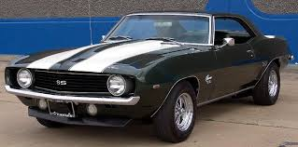
Blast from the past
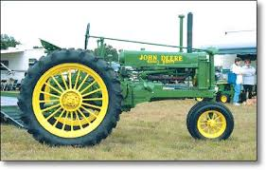
Winona ANTIQUE Tractor Show & pull

Winona Chamber of Commerce is hosting a Classic Car Show as well.
Registration: 7:00 a.m.-8:00 a.m.
Location: Winona High School
611 Wildcat Drive
Winona, Texas 75792
Directions:
From I-20 take Exit for 155 N towards Big Sandy. Turn left at the flashing red light at 16. When you reach the Fire Station, turn left onto Wildcat Drive. You will see the school entrance on your right.

From Lindale, head East on Hwy 16. Cross 14 and when you see the water tower, turn right onto Wildcat Drive, next to the Fire Station. Entrance is on your right.

Tractor Pull begins at 9:00 a.m.
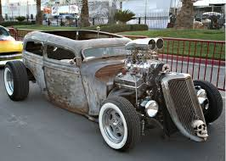
Car & Truck Show begins at 10:00 a.m.

For information, call:
Bruce Burnham: 903-521-6450
Casey Willis: 903-714-6372
Ron Davis: 903-850-6503

Awards: 1st – 3rd each weight class, People’s Choice, King of the Hill, etc.

Benefitting the Winona FFA Alumni and the Winona Chamber of Commerce Scholarship funds.

There will be a concession stand available hosted by the Winona FFA Alumni.

Arts and crafts vendors will be set up.

Winona FFA Plant Sale will be from 10:00 a.m. to 2:00 p.m.

